As you are well aware by now, EKG interpretation is one of those things in medicine we all struggle with. It is not an intuitive experience and the squiggly lines resist a sane approach to their deciphering. What follows is an old (because I am old!) approach, tempered by more than thirty years of learning, teaching, forgetting and then relearning the details. My methods are based upon vectorcardiography, more so than “pattern recognition” because that is the way I was trained. At first this approach is a bit intimidating and difficult to get your mind around, but once the basic concept is etched into your thinking, the “patterns” we see will make much more sense.
Perhaps the most important concept of EKG interpretation to grasp is that an EKG is a view of a single event (the depolarization/repolarization of the heart)… albeit from twelve different view points. Although I don’t do football (I went to a game once… so give me a break!), an EKG and a game have a lot in common. Think of the game as the details of depolarization/repolarization going on in the heart during a cardiac cycle and viewed from twelve different spectators (12 leads) sitting at various places around the arena. Spectator V1 sitting in the Goodyear blimp sees a pass thrown very differently than Spectator AVF sitting in the end zone at the ground level. Spectator Limb Lead I sitting at the ground level on the 50 yard line sees it still quite differently. Nevertheless, all three viewers/leads are watching exactly the same sequence of events. How they record the event is very dependent upon the event itself, but also the angle/view from which they see it unfold. If you don’t get this idea, little else I say will make any sense. Think of a vector (the pass of the football from the quarterback to the receiver) as having both direction and force (how far the pass is thrown… or the voltage of the depolarization).
If the vector/pass is moving toward Spectator AVF, then AVF will record the event (the QRS) as an upward/positive deflection from the baseline on the EKG paper.
→ 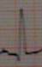
By the same token, if the vector is moving away from Spectator AVF, it will record the event (the QRS) as a downward/negative deflection on the EKG paper.
→ 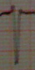
Understanding this concept is crucial to EKG interpretation. In other words, by knowing that the heart is basically in the same place in the chest and situated at the same angle (dextrocardia notwithstanding) in that position, and knowing that each of the 12 leads are situated in the same spectator’s position each time an EKG is done, we can anticipate how each lead should look on the EKG paper. When each lead appears with the direction (upward or downward deflection) and voltage (the height/depth of that deflection) we anticipate it to have, we can know the cardiac event (depolarization/repolarization) is taking place in the normal fashion. When a part of that process is not normal, we can pick it out of the sequence of events by knowing what each lead should have looked like in advance. The little axiom stated at the top of my EKG Interpretation Outline states this another way… “the eye sees only what the mind already knows!” For example, if you don’t already know what V1 is supposed to look like (a downward deflection), then you may not recognize it when a RBBB distorts its vector causing its deflection to be opposite from it’s normal direction.

QRS Limb Lead Vector Analysis
Continuing this thought process, we should understand that the limb leads (I, II, III, AVR, AVL, & AVF) are situated at the ground level in the stadium and the chest leads (V1, V2, V3, V4, V5 & V6) are situated with V1 and V2 in the Goodyear blimp and V3/V4 about at the 50 yard line at ground level and V5 and V6 actually viewing the game from underneath the turf beneath the game. In other words, these two sets of leads are seeing the game from two different (but nearly perpendicular) planes. Think of a person lying on the game field with his head toward one set of goal posts and his feet toward the other goal posts. The long axis of his heart (although in the center of the field) would be angled toward his left leg. The limb leads are, by default, laid out such that limb lead I is toward the person’s left arm, lead II situated at his left foot, AVF between his left and right foot, III toward his right leg and AVR toward his right arm. The sinus node is a microscopic cluster of cells located in the roof of the right atrium up near the base of the heart (toward the right clavicle of our host lying on the field). The apex of the host’s heart is toward his left leg. Knowing that the depolarization (reflected by the QRS) of the heart starts in the sinus node and basically propagates down the length of the heart toward the apex, then you can intuitively see that the wave (vector) of depolarization (the QRS) is moving toward the host’s left leg/foot… i.e. toward limb lead II. 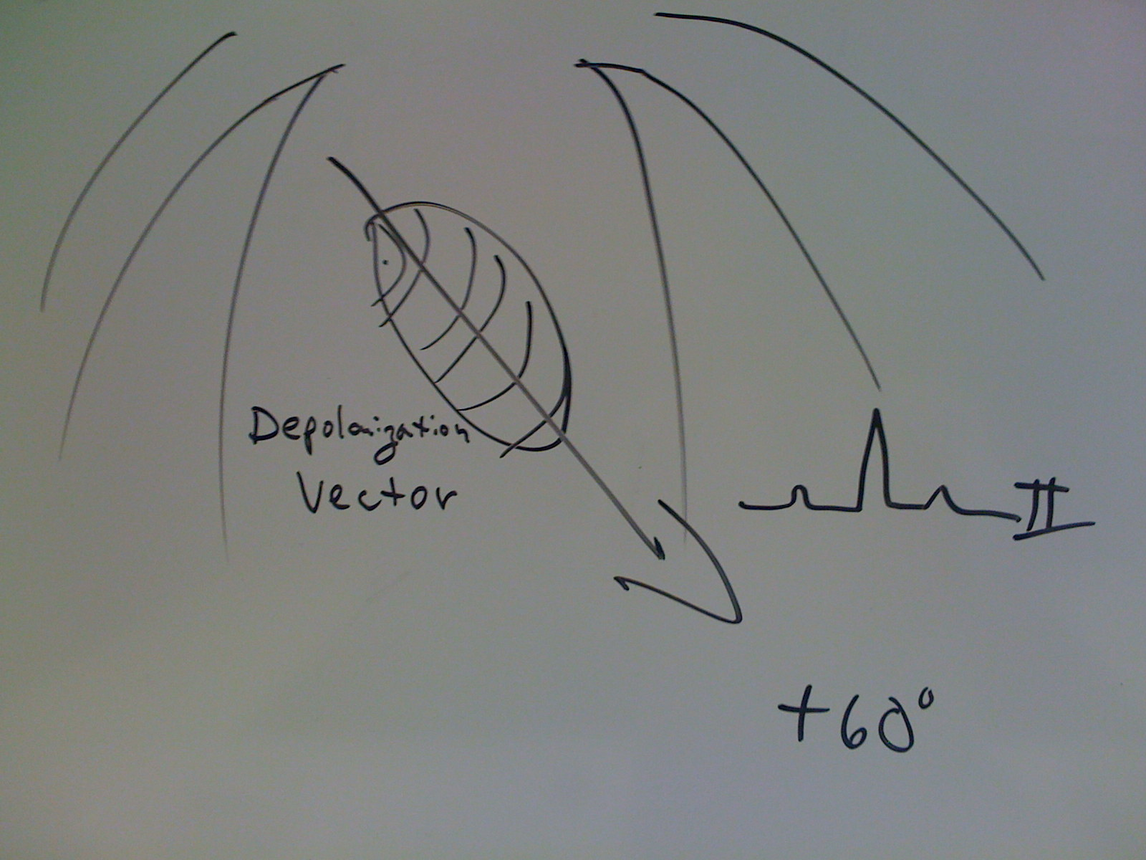 Hence, what should limb lead II always look like on the EKG paper? It should be an upright deflection, right? And indeed, it is… at least when the QRS axis is normal. 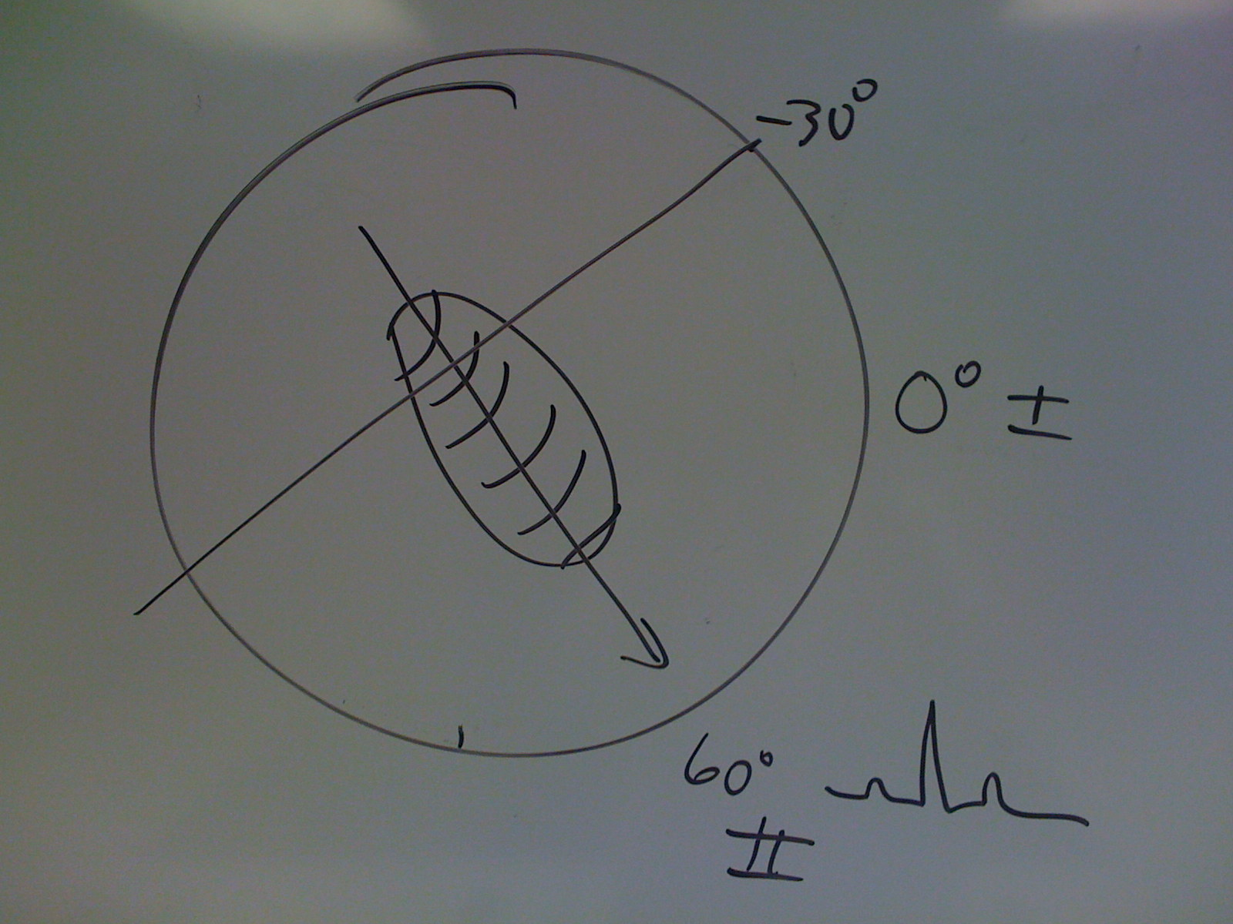 But what if the QRS axis is leftward (left axis deviation)… toward the person’s left shoulder? Then, indeed, limb lead II will be a negative deflection… 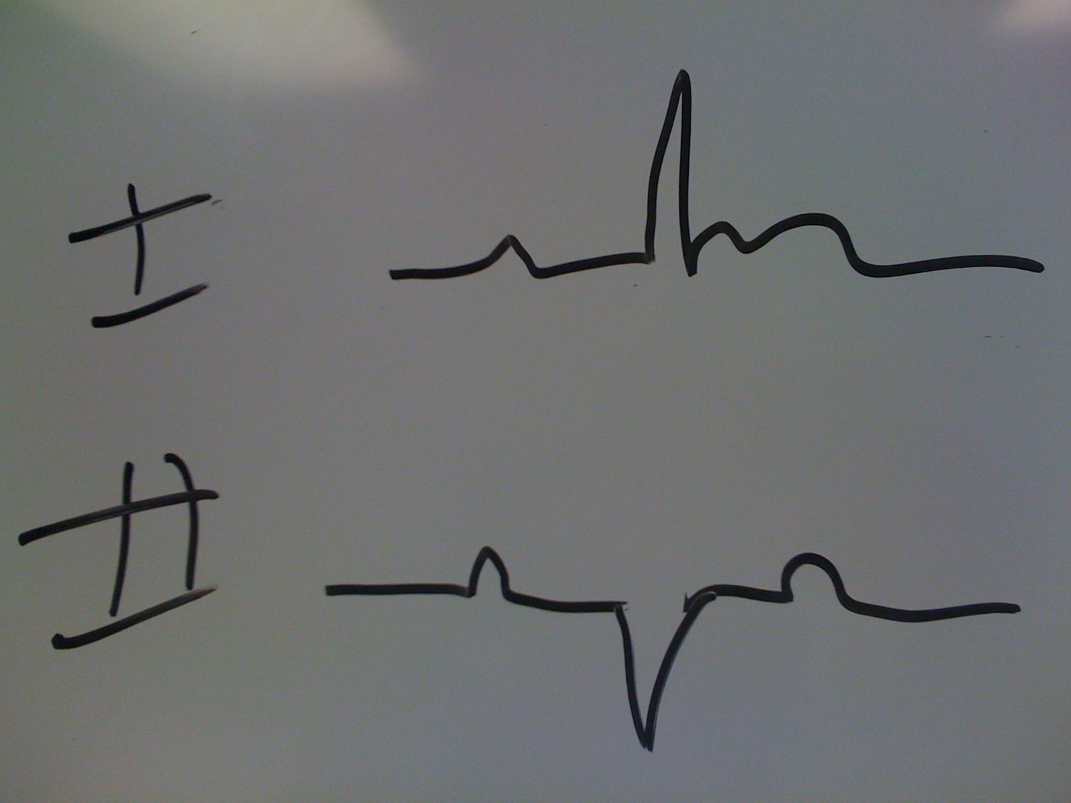 while lead I remains upright. What about limb lead I (located at the host’s left arm position)? Although the depolarization vector is not moving exactly toward limb lead I, it is moving relatively toward limb lead I. As a result, limb lead I will always be an upright deflection when the QRS axis is normal 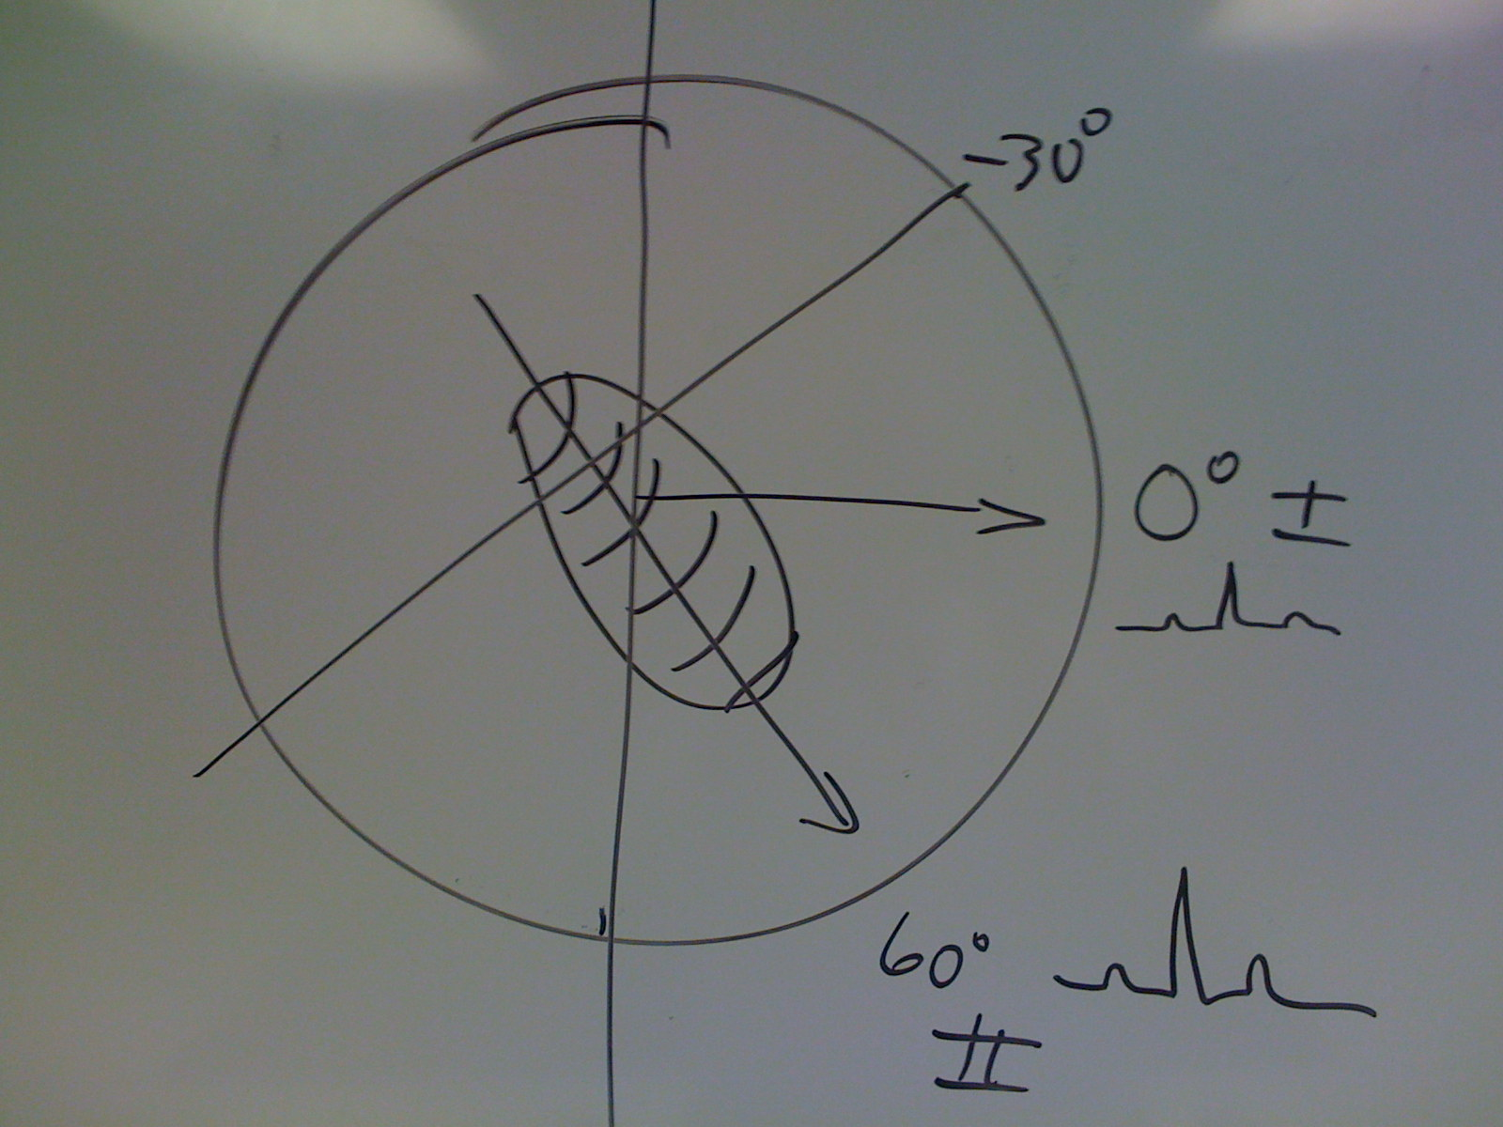 although it may have a lower voltage (QRS not as tall) as in limb lead II. But what if the QRS axis is rightward (Right Axis Deviation)? Then, the vector is moving away from limb lead I and it will be a negative deflection on the EKG paper. 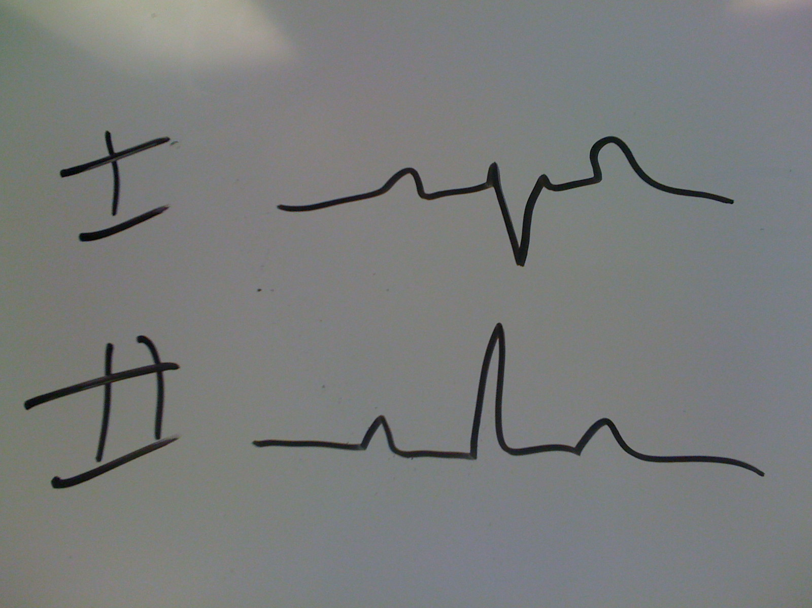 To summarize, 1) if limb lead II is a negative deflection, you have a left axis deviation. 2) if limb lead I is a negative deflection, you have a right axis deviation. If both are negative deflection, you have an “indeterminant” QRS axis (the vector is propagating in a plane that is likely perpendicular to the plane of the limb leads, or the limb leads have been reversed by mistake). 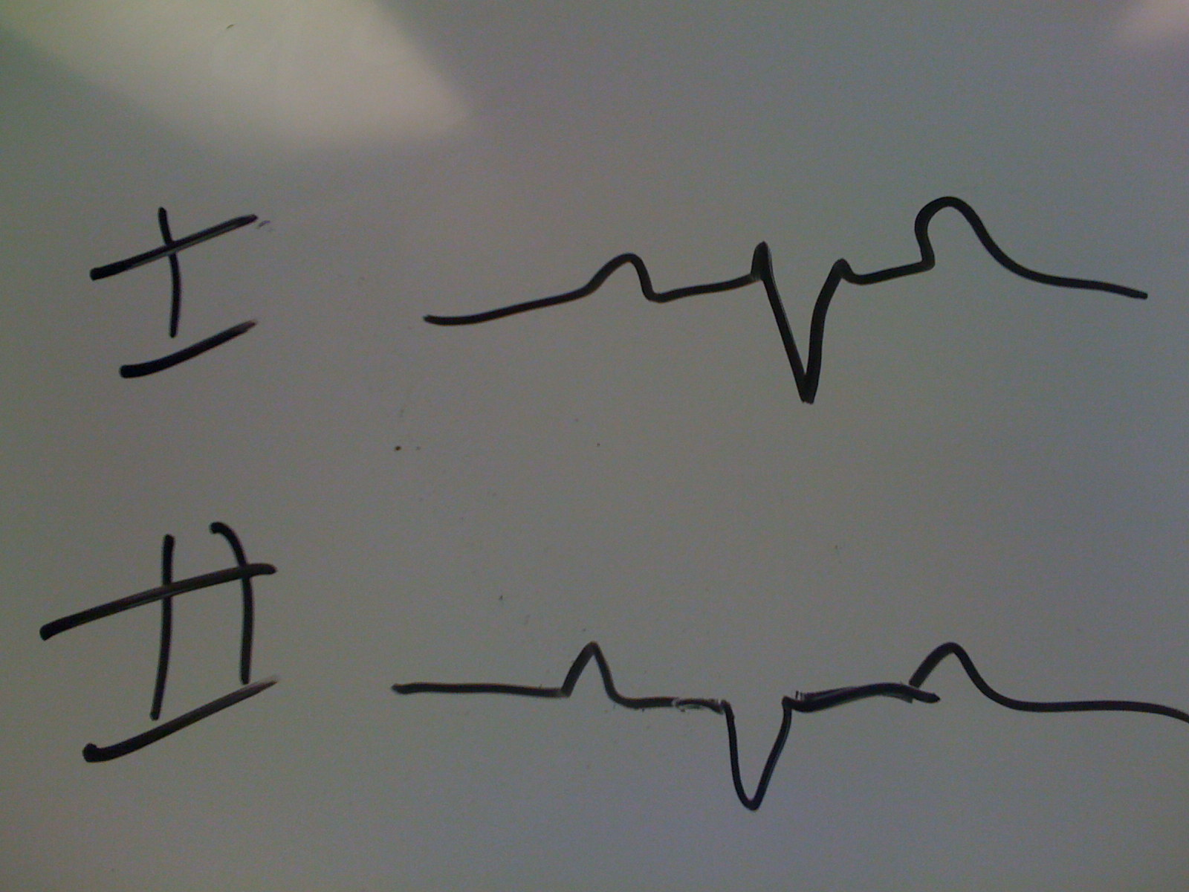

QRS Chest Lead Vector Analysis
Continuing to look at the depolarization event of the heart, now let’s look at this same event we just considered from the limb leads’ perspective but now using the chest leads. Where, relative to the heart, is chest lead V1 located… below the heart, even with the heart, or above the heart? By convention, it is located along the right upper sternal border and above the base of the heart [and therefore will see the wave of depolarization that propagates from the base toward the apex as going away from it… it will always (when normal) be a negative deflection]. Where is V6? Well, by convention, the chest leads are stuck on the chest in such a way that they angle across the chest placing V1 above the heart, but by the time you get around to V6, it is lying below the apex of the heart. V2 is very similar to V1 in that it is at the left upper sternal border, but still above the base of the heart. To take this rationalization a step further, just look at a few normal EKG’s starting with the R wave in V1. You will find that the R wave in V1 is always very small. The R wave in V2 is a little bigger than the one in V1. The R wave in V3 is still a bit larger (but still typically smaller than the S wave) than in V2. The V4 R wave is still larger. By the time you get around to V5, the R wave is consistently larger than the S wave. Same is true for V6 R waves. We call this axis determination by a different name (by convention) in the chest leads. We call it “R wave Progression”. In other words, as you move across the chest leads from V1 toward V6, you see the R wave get progressively larger until the R waves in V5 and V6 are virtually always larger than the S waves in these two leads, if that progression is normal. When the Rave in V5 and or V6 is smaller than it’s S wave, we call this “poor R wave progression”. In other words, in exactly the same way the QRS vector is shifted in the limb leads either leftward or rightward (LAD or RAD), a shift of the QRS vector away from its usual direction is called “poor R wave progression”. Instead of calling it an “axis deviation”, we term it “poor R wave progression”. It is still a vector analysis in the same fashion we analysis the QRS vector in the limb leads and call it an “axis deviation”.

T Wave Vector Analysis (Nonspecific T wave Changes)
Now with this backdrop of understanding of the basic QRS depolarization vectors in the limb leads (the QRS axis) and the QRS axis in the chest leads (the R wave progression), we are ready to consider the repolarization vectors in the limb leads and the chest leads. What particular aspect of the EKG represents repolarization? Well, it’s obviously not the QRS complexes. The T waves represent the repolarization of the heart on the EKG strips. What might you guess would be the direction of the repolarization vector? Well, it should not be much of a surprise to find that it propagates in very much the same direction as the depolarization vector… in both the limb leads and the chest leads. In other words, would you expect the T waves in limb leads I and II to be positive… or negative deflections? They will always (when normal) be upward/positive deflections. The same is the case for chest leads V5 and V6, and for the same reason we found the QRS to be upright/positive deflections in these two leads. Oddly enough, we have by convention given the T wave axis a unique name, and we have by convention lumped the determination of the T wave axis in the limb (I and II) and chest (V5 and V6) leads together and refer to these vectors as “T wave changes”. When the T wave axis is normal, the T waves in limb leads I and II and chest leads V5 and V6 are all upright: 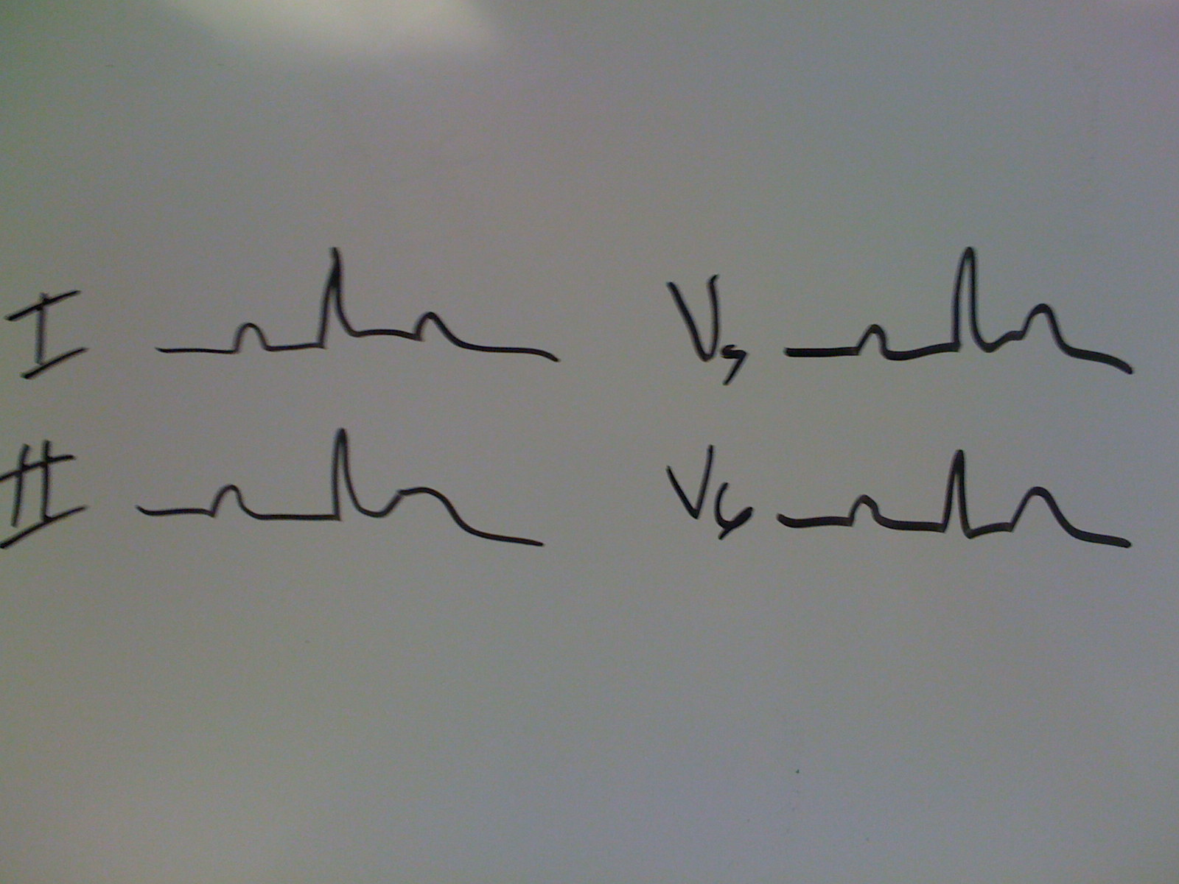 However, when the T wave axis is not normal, we refer to this as “Nonspecific T wave changes”. In other words, when the T wave vector is outside its normal range in the limb leads (the limb I and/or II T waves are flipped/inverted/negative deflections → T wave axis is less than minus 30 degrees or greater than plus 90 degrees), and/or the T wave axis in the chest leads is outside its normal range (the T waves in V5 and/or V6 are inverted/flipped/negative deflections) we refer to these changes collectively as “Nonspecific T wave changes”. Let me say that another way. If a T wave in any one or more of these leads (I, II, V5, V6) is inverted/flipped/negative, then we call this Nonspecific T wave changes. For example: 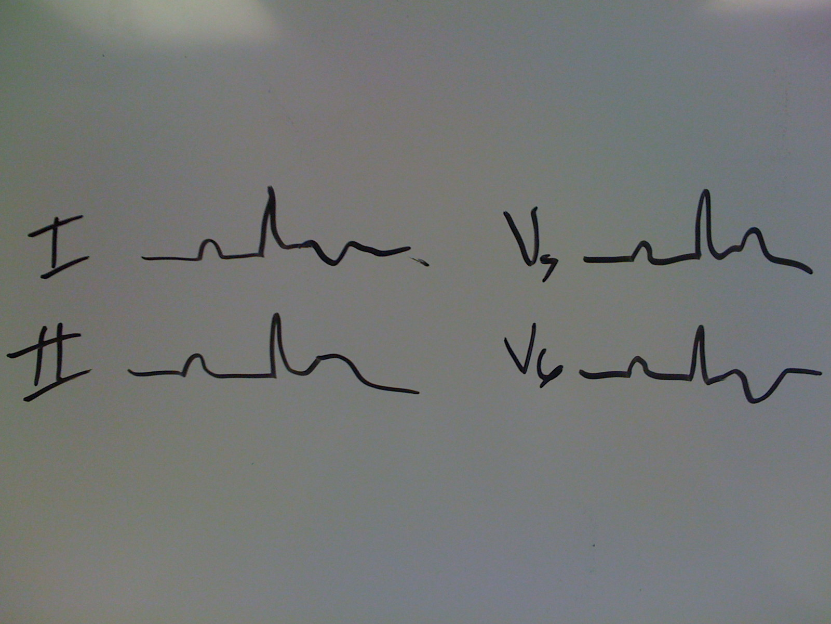 But what does this really mean to the patient. In other words, what kinds of problems will shift the T wave axis outside its normal range? Well, as you might guess from the title “nonspecific”, any one or more of a host of conditions will shift this very small vector from its normal range. Things like hypokalemia, hypomagnesemia, hyponatremia, hypocalcemia, hypercalcemia, hypothyroidism, ischemia, infarction, pericarditis, stroke, PTE, and on and on. At first blush, you might think that such a sensitive indicator with some many factors affecting it, that it would be nearly worthless as an EKG finding. That, however, is not the case. In fact, day in and day out, this very sensitive, but nonspecific EKG finding turns out to be one of the most useful changes we look for. More on this later when we discuss ST segment changes.
Now, having made a big deal of assessing the “T wave axis”, let’s take a moment to distinguish other “T wave changes” that may point to underlying pathology even when the “T wave axis” is normal in both the limb and chest leads. When the T waves (particularly in the lateral chest leads) are upright but “peaked” (i.e. taller than about 10 mm), these T wave changes can suggest underlying hyperkalemia. When the T waves are very high voltage (10 to 15 mm or more) in V1-V3 (but inverted as they should be), this may signal a lethal acute coronary syndrome called Wellen’s Syndrome. There is a more subtle Type II Wellens with large biphasic anterior precordial Twaves, but the point here is that the T wave axis may (and likely is) normal in this situation, yet the T wave changes have a very high correlation with high grade LAD coronary lesions when the rest of the clinical picture is present. So, sometimes T wave changes can signal trouble even when the T wave axis is normal.

Coronary Atherosclerotic Changes
Before we go any further with the details, I think it’s worth pausing a moment to just get all these details in perspective of importance. If you ask yourself the question, “Why do I order EKG’s?” What comes to mind? The answer should be, “coronary atherosclerosis”. For the most part, we order EKG’s looking for evidence of underlying coronary disease. If we stumble across an occasional Brugadas, Loundes/Ganong/Levine Syndrome, or a dextracardia, certainly we’d hope that we could recognize them. But these oddities are not what we are looking for most of the time. If that’s the case, then I think it would be prudent to have in mind the top four or five EKG changes that might be associated with underlying coronary atherosclerotic disease in its various forms (prior infarctions, acute coronary syndromes, intermittent ischemia, etc.):

Prior Myocardial Infarctions → Pathologic Q waves
Ischemia → ST segment depression and QT prolongation and Nonspecific T wave changes
Acute Myocardial Infarctions → ST segment elevation with reciprocal ST depression and T wave axis changes
Conduction Defects → RBBB, LBBB, NIVCD’s

ST Segment Changes
The vast majority of EKG’s performed are done so looking for pertinent ST segment changes. Yet, I have been amazed at how poor our skill in sorting out the abnormal ST segment changes from those that occur on a high percentage of completely normal EKG’s. First let’s take a look at the two types of ST segment changes → ST segment elevation and ST segment depression. They are vastly different, yet often related. The students have come to expect my standard question, “If I gave you a hundred EKG’s and told you they all had ST elevation, what percentage would be normal?” The answer: NINETY FIVE PERCENT!!! If I told you the serum Na was 126 and that I was certain of it within a 95% confidence limit, you would say, “Fine, I’m satisfied with that”. But with EKG’s that is not good enough. Missing the 5% that represent most of the acute MI’s is not acceptable. Therefore, we must learn to sift the ST segment chafe with great sensitivity/specificity. So, how do we sort out those five or so percent that represent what we call an “injury current” [ST segment elevation that really does represent cell death at the myocardial (acute MI) or epicardial (pericarditis) level]? The answer is… “by the company they keep”. What I mean by this is that ST segment elevation that occurs in the absence of two other types of EKG changes are virtually certainly due to a variant of normal we refer to as, “early repolarization” (ST segment elevation that is a variant of normal… has no clinical significance and can, in the vast majority of cases, be ignored). What are those two other EKG changes that generally accompany the ST elevation that is likely due to an injury current? 1) our beloved Nonspecific T wave Changes, and 2) reciprocal ST segment depression (more on this in a moment). In other words, when you see ST segment elevation and Nonspecific T wave changes occurring together on the same EKG take it seriously. Remember that this really means an abnormal T wave axis in either the limb leads, the chest leads, or both → or said another way, T wave inversion in any of 4 leads… I, II, V5, V6. Now, let’s look at these two situations in some detail
1) The finding of ST elevation with accompanying Nonspecific T wave changes found on the same EKG: I’ll ask the rhetorical question with a twist: “If I gave you 100 EKG’s and told you they all had both ST elevation and Nonspecific T wave changes, what percentage would represent real underlying cardiac injury (cell death)?” The answer: about FIVE to TEN PERCENT. You might say, “Well, that’s not very sensitive.” Granted, but are you OK with missing 10 % of all acute MI’s? So, these are patient’s who present with the classic “chest pain R/O MI” that you take more seriously… admit, monitor, serial EKG’s, serial enzymes and stress imaging the next day if these initial parameters are OK.
2) The finding of ST elevation with accompanying Reciprocal ST depression found on the same EKG: Again, with the rhetorical question: “If I gave you 100 EKG’s and told you they all had both ST elevation and Reciprocal ST segment depression, what percentage would represent real underlying cardiac injury (cell death)? The answer: NINETY PLUS PERCENT!!! Suddenly here we have a set of EKG changes that predict myocardial injury with a high degree of sensitivity and specificity. Obviously, this is a set of EKG changes we don’t want to ever overlook. So, what exactly is, “reciprocal ST segment depression”. Well, the word reciprocal connotes opposing. Consider an EKG’s traditional layout on a single sheet of 8.5 x 11 sheet of paper in the following pattern: 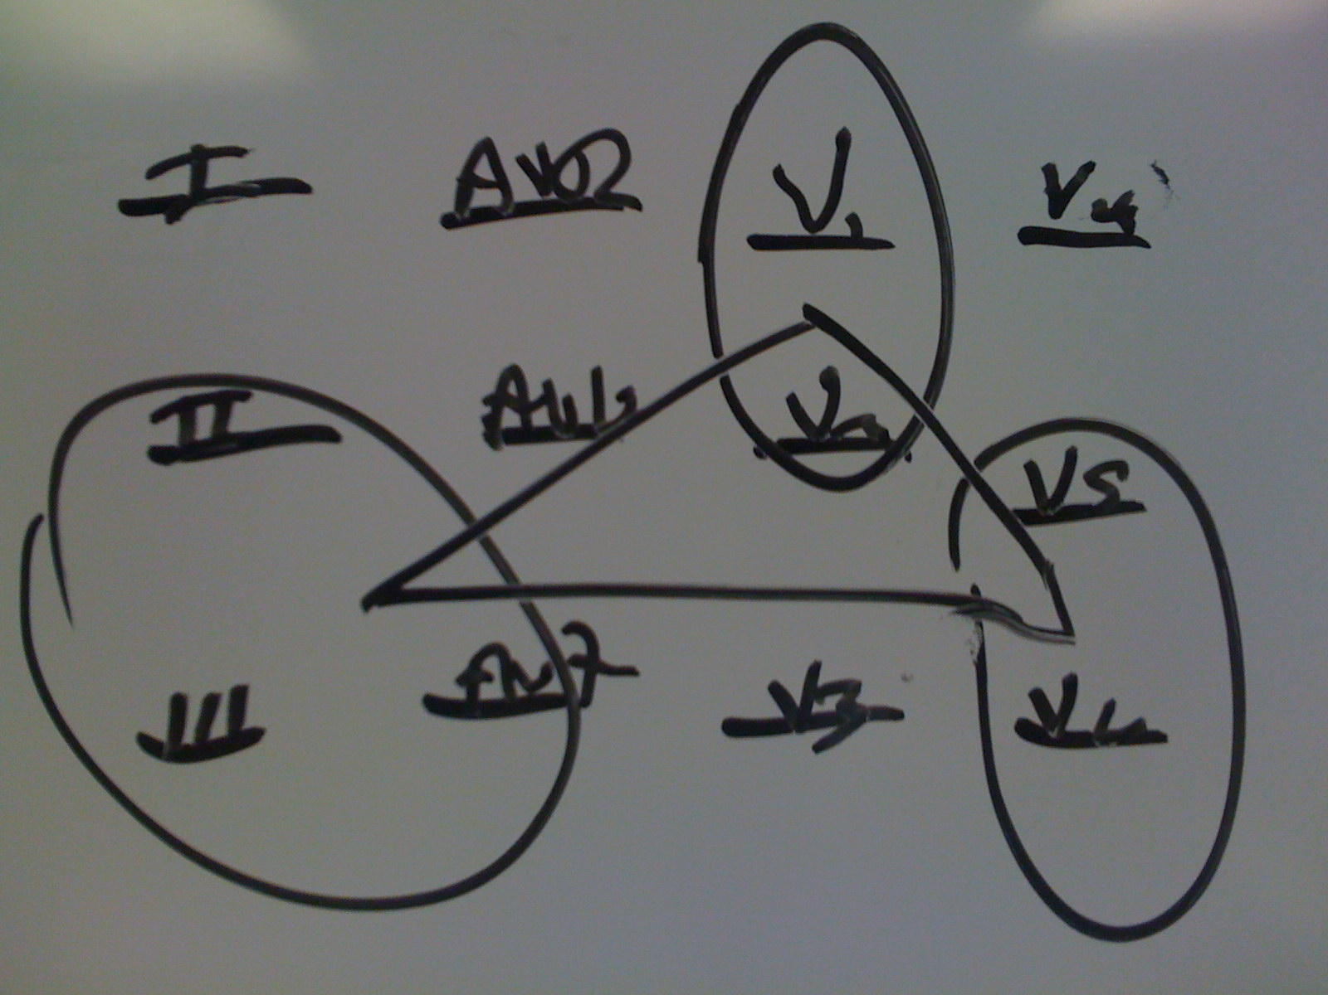 [see the triangle → anterior (V1-3), lateral (V5-6) and inferior (II, III, AVF)] When you see ST segment elevation in (for example) V1, V2 → then look for reciprocal ST depression in II, III, AVF and/or V5, V6. Using the same logic, if you see ST elevation in II, III, AVF → then look for reciprocal ST depression in V1, V2 and/or V5, V6. Although there are other patterns, these are the most common. But just remember that if you see ST elevation and ST depression on the same EKG → take note!!! It likely represents trouble. AVR is a notable exception.
There are other causes of ST elevation we should also consider:

Acute MI
Injury

Pericarditis
ST Elevation
NIVCD (NonspecificIntraVentricular Conduction Defect)
Early Repolarization (90 to 120 msec)
Conduction Defects LBBB (>120 msec)
Aneurysm
Prinzmetals RBBB (>120 msec)
Brugadas

Now, let’s take a look at ST segment depression aside from its role in acute myocardial events like an acute MI where you frequently see injury and ischemia simultaneously on the EKG. Asking the same rhetorical question, “If I gave you 100 EKG’s and told you they all had more than 1 mm of ST depression, but no ST elevation, what percentage would represent real underlying cardiac ischemia?” The answer: NINETY FIVE PERCENT!!! Unlike ST elevation, which in most cases will represent innocent early repolarization. However, when you see ST depression on an EKG, it usually represents a serious problem… ongoing ischemia or sometimes due to LVH, sometimes coronary disease. There are, however, other causes.
Ischemia

ST Depression LVH
NIVCD (NonspecificItraVentricular Conduction Defect )
Digitalis Effect (90 to 120 msec)
Conduction Defects LBBB (>120 msec)

RBBB (>120 msec)
As the diagrams above suggest, there are a host of other causes of both ST elevation and ST depression. Let’s explore these for a moment. Perhaps the most important are conduction defects (Nonspecific conduction defects, LBBB and RBBB). It is crucial to remember that when you see any of these defects in conduction on an EKG, they will almost uniformly cause ST segment changes (often both elevation and depression) as well as T wave axis changes (nonspecific T wave changes). That means that when there is a conduction defect present, it next to impossible to sift out the underlying cause… hence you simply don’t comment. If you think about this for a moment, it really brings home what a problem conduction defects can cause. What are the most common EKG changes reflecting underlying coronary atherosclerosis we mentioned earlier? Let’s review them:

Prior Myocardial Infarctions → Pathologic Q waves
Ischemia → ST segment depression and QT prolongation and T wave axis changes
Acute Myocardial Infarctions → ST segment elevation, reciprocal ST depression, and T wave axis changes

Conduction Defects → RBBB, LBBB, NIVCD’s
Notice that even though conduction defects often preclude our seeing the underlying evidence of coronary artery disease (ST segment and T wave axis changes), they cause these defects themselves. But, what is the most common cause of a conduction defect… coronary artery disease! So, the very thing they mask is also their most common underlying cause. I think we often don’t think of conduction defects in this way. In other words, we don’t assign nearly enough significance to them. If a person presents with a new LBBB, RBBB or NIVCD, think of that as an angina equivalent. Those patients should be evaluated for other evidence of underlying coronary artery disease.
Aneurysm formation is an uncommon, but potentially lethal (CHF, arrhytmias, stroke) complication and the EKG may be your only clue one is developing until disaster hits. The best way to recognize this pattern is the first few days to weeks following an acute MI. Checking an EKG on the day of discharge and/or on the first clinic visit following an acute MI will reflect persisting ST elevation in the original MI pattern. For example if you had marked ST elevation in II, II and AVF and a few days later find the ST elevation did not resolve… think ANEURYSM and check an echo.
Prinzmetals angina is a classic cause of ST elevation but its hallmark is the fact that one minute it’s there and the next it is not. It comes and goes often tracking the patient’s chest pain.
Brugadas is one of those rare syndromes that is much more common in some patient populations like those with a lot of Italians in them. We have very few cases of Brugadas in our patient population. Having read more than 300,000 EKG’s in the last 40 years, I have only seen one case of Brugadas. I think I’d recognize it most of the time when I see one, at least the Type I (There are three subtypes). The hallmark is a downsloaping ST elevation in chest lead V1. Even though the underlying pathophysiology here is a type of ventricular re-entry, it is not the same as the “re-entry” type “preexcitation” syndromes… LGL and WPW that occur in the region near the AV junction.

Rate and Interval Measurements
Most begin the interpretation of an EKG with a rate determination and subsequent measurement of intervals, and indeed, I do as well. But, I’ve found in teaching that students seem to do better when this is left toward the end of the details covered above. They seem to get the rate/intervals with little trouble.
The key to measuring intervals and rate is to understand the default standards upon which those QRS complexes are recorded. The paper has a background grid composed of horizontal and vertical lines. 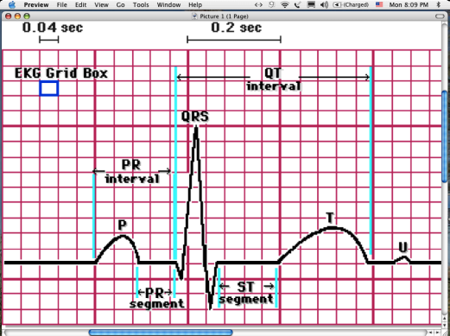 The voltage of each QRS is measured in milivolts reflected by how tall the QRS is against the lines. The distance between two dark horizontal lines is 5 mv. And the distance from one thin horizontal line to the next is 1 mv. The distance (in time) from one of these vertical lines to another is measured in milliseconds. The time from one dark vertical line to the next is 200 ms. The distance from one of the smaller lines to the next is 40 ms. Against that grid, the length (in milliseconds) of the PR 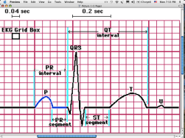, QRS 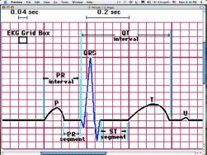, and QT 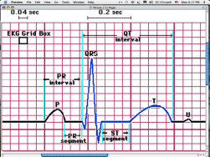 can be pretty accurately (to within about 5 to 10 ms) measured. The normal range for a PR interval is from about 120 to 200 ms. The range for the QRS duration is about 50 ms to 90 ms A QRS with an interval of 90 to 120 ms, we refer to as a NIVCD (nonspecific intraventricular conduction defect) . A QRS interval ≥ 120 ms is either a RBBB (V1 → ) or LBBB (V1 → 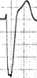). Because a RBBB and LBBB have an overlap of interval length, we must have other EKG criteria to recognize which we are looking at. The classic “rabbit ears” (RSR´) pattern in chest lead V1 represents the easiest way to recognize a RBBB, but some RBBB’s have odd patterns in V1 → such as the QR pattern seen with a RBBB in combination with a prior anteroseptal MI (a QR pattern). But virtually all RBBB’s have another clue… very large terminal S waves in limb lead I and chest lead V6 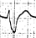. By the same analysis, a LBBB has four typical findings → 1) a wide QRS (> 120 ms), 2) a downward deflection in V1, 3) anterior (V1-3) ST elevation and 4) lateral (V5-6) ST depression and T wave inversion).
There are two basic methods of rate determination. The quickest and most simple is to pick a QRS that happens to fall exactly on a dark line of the EKG background grid. With each subsequent dark vertical line, an analog rate scheme is applied as follows → 300, 150, 100, 75, 60, 50, 30, etc. 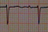
The rate in this example is almost exactly 100/min. Here’s one with a rate of about 80/min… 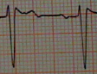. But if the QRS to QRS interval is irregular (e.g. atrial fib) 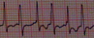, you may need to count the number of QRS’s on the ten second standard EKG and multiply by six. This will always give you a more precise estimate of the heart rate. A review of the common arrhythmias is beyond the scope of this paper and will be covered separately.

LVH and RVH
LVH carries some pretty terrible risk for sudden death as well as the development of arrythmias, cardiomyopathies, coronary artery disease, etc. And importantly, this is a potentially reversible problem and therefore, we should look for it in all EKG’s regardless of the reason they are recorded. There are multiple criteria published (Romhilt-Estes, Lyon’s, Sokolov’s, etc.) The most commonly used is the Romhilt-Estes. There are two components to it’s application… 1) voltage (>20 mm R or S in any limb lead or > 25 mm R or S in any chest lead) plus 2) secondary criteria (NST wave changes, atrial enlargement, ST changes, intrinsicoid deflection, LAD).
RVH has three primary criteria (an R in V1 > 7 mm, an R in V1 that is greater than the S in V1, or an S in V1 that is less than 2 ms) and two secondary criteria (RAD or poor R wave progression).

A. Robert Sheppard, M.D.
Associate Professor of Medicine
Director, Hospitalist Services
College of Community Health Sciences
University of Alabama School of Medicine

The following is a chart for calculating the QTc (the QT corrected for rate/gender/age). This chart is a very conservative one. In other words, some references us a bit more generous measure for a given rate. As an example, for a rate of 60 in adult men, the upper limits of the QT is .44 as compared to .422 in this reference.

Upper limits of normal QT intervals for given heart rates for men/children and women).

HR men/children women
40 0.491 0.503
43 0.479 0.491
46 0.466 0.478
48 0.460 0.471
50 0.453 0.464
52 0.445 0.456
55 0.438 0.449
57 0.430 0.441
60 0.422 0.432
63 0.413 0.423
67 0.404 0.414
70 0.395 0.405
75 0.384 0.394
80 0.374 0.384
85 0.363 0.372
90 0.351 0.360
100 0.338 0.347
110 0.325 0.333
120 0.310 0.317
135 0.294 0.301
150 0.275 0.282
175 0.255 0.262

Sheppard’s Rapid EKG Interpretation Patterns
The eye only sees what the mind already knows...
http://www.BobSheppard.com

Rate (300, 150, 100, 75, 60, 50, 30...) or if irregular count QRS's x 6
Rhythm (Normal sinus, sinus arrhythmia, Ectopic Atrial Rhythm, Atrial Fib/Flutter, SVT, etc)
PR (0.13 to 0.20), QRS (.06 to 0.08), QT (< 0.45 but rate, age and gender dependent)
Each small block on the ECG paper is .04 sec. and each large block is .20 sec.
QRS Limb Lead Axis (QRS should be upright in limb leads I and II)

(Abnormals are → "Right Axis Deviation” and “Left Axis Deviation"
QRS Chest Lead Axis (QRS should be upright in V5 and V6)
(This is also referred to as... "Poor R wave progression”.)
Limb Lead T wave Axis (T wave should be upright in limb lead I and II)
Chest Lead T wave Axis (T wave should be upright in chest leads V5 and V6)
(i.e. inverted T waves in I, II, V5 and/or V6 means Nonspecific T wave changes)
Q's: V1 and AVF (significant means having Q's > 30 ms wide and > 2 mm deep)
ST elevation: V1-4 and II, III, AVF (> 0.5 mm)
Injury (Early Repolarization , Infarction, Pericarditis, Aneurysm, Prinz Metals, conduction defects, etc.)
ST depression: V5-6, II, III, AVF (> 0.5 mm (>2 mm in two contingous leads to warrant thrombolytic)
Ischemia, digitalis effect, or conduction defects.

Acute MI
Injury

Pericarditis
ST Elevation
NIVCD (NonspecificIntraVentricular Conduction Defect)
Early Repolarization (90 to 120 msec)
Conduction Defects LBBB (>120 msec)
Aneurysm
Prinzmetals RBBB (>120 msec)
Brugadas

Ischemia

ST Depression LVH
NIVCD (NonspecificItraVentricular Conduction Defect )
Digitalis Effect (90 to 120 msec)
Conduction Defects LBBB (>120 msec)
AV Block
First Degree (PR > 0.20 sec) RBBB (>120 msec)

Second Degree (Mobitz Type I (same as AV Wenckebach) and Mobitz Type II
Third Degree (Complete heart block)
Pre-Excitation Syndromes
WPW → Wolfe Parkinson White Syndrome (short PR w/Delta wave)
LGL → Lown Ganong Levine and EAVNC Syndrome (short PR w/no conduction defect)
Brugadas → (downsloping ST elevation → V1, V2 mimicking a RBBB pattern)

Voltage criteria for
LVH: V5-6 > 30 mm (basically in any of the chest leads) or > 20 mm in any limb lead

RVH: R>S in V1, R>7 mm in V1, or S<2 mm in V1, w/RAD as a secondary criteria
Low Voltage criteria: < 5 mm in all limb leads
Right Atrial Abnormality: > 3 mm tall P in Limb Lead II or 2 mm tall initial positive deflection of P in V1
Left Atrial Abnormality: Terminal portion of P >1 mm deep and 40 ms wide in V-1 or 120 ms P in limb lead II
Dextrocardia: Complete reversal of R progression in chest leads + inverted P’s in limb leads I & AVL.

